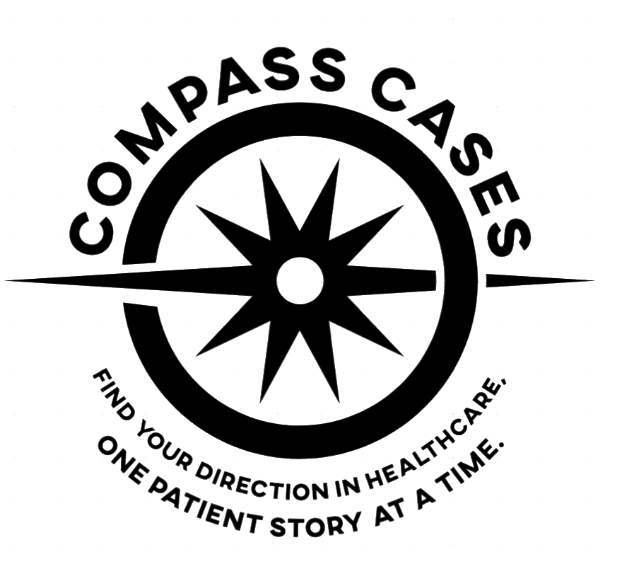
PRE-HEALTH CAREER EXPLORATION SERIES
About Compass Cases
Find your direction in healthcare, one patient story at a time.

Compass Cases is a pre-health career-exploration experience from Stanford University School of Medicine, built to close a long-standing gap in how students discover healthcare careers. Students are often drawn to healthcare early, but rarely encounter the full range of clinical roles until they are already deep into training. Most can name a physician, a nurse, a therapist; the pharmacy technician, genetic counselor, respiratory therapist, community health worker, and dozens of others stay largely invisible during exactly the years when career choices are being formed. The problem was never a lack of interest — it was the lack of a map.
The experience hands students that map through three cases inspired by real patient stories — Jordan’s red eye that proves to be an autoimmune diagnosis, Emma’s flu complicated by an unexpected pregnancy, and Andre’s asthma set off by wildfire smoke. In each, learners follow one patient outward through the whole ecosystem of people who make their care possible, step into each professional’s role, and take a short Career Compass that helps them notice how they want to work.
Its purpose is to be an introduction that stimulates curiosity — it rewards the question “why” and broadens the careers a learner would seriously consider.
Importantly, Compass Cases is not a substitute for real experience but preparation for it. It primes students for the encounters that matter most — shadowing, mentor conversations, and time with real patients and providers — so they arrive with their questions already formed rather than starting cold.

C O M P A S S
Career Opportunities Mapped through Patient Stories And Shadowing
Compass Cases · Stanford University School of Medicine

