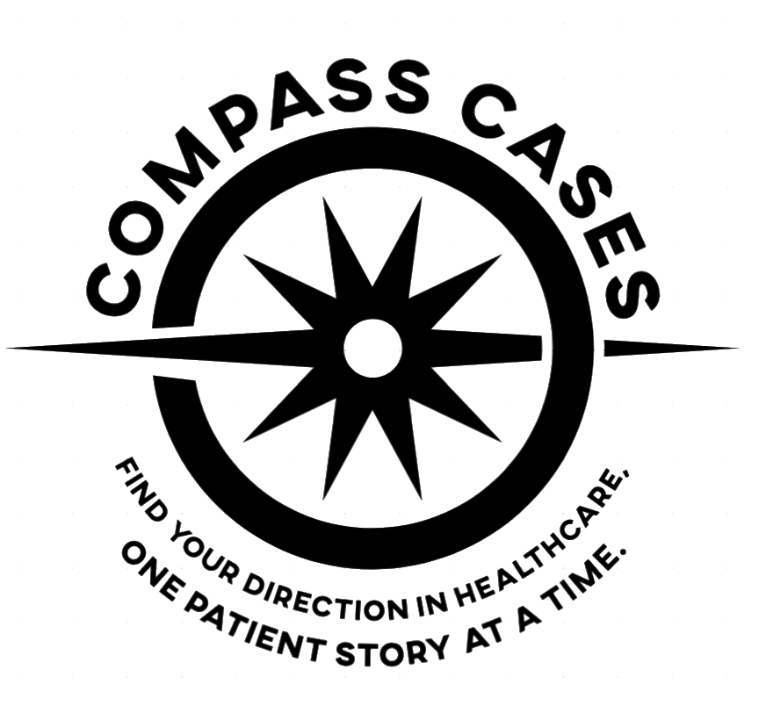
Compass Cases · Stanford University
Pre-Health Career Exploration Series

Career Compass
An interactive tool for pre-health career exploration

Overview
The Career Compass is a standalone, browser-based self-assessment tool designed to help high school and college pre-health students explore the breadth of careers in healthcare. It is built around the fourteen professionals who appear in Compass Cases Case Two: The Same Patient, Fourteen Different Eyes – Jordan Chen’s journey from a red eye at 8:20 a.m. to a diagnosis of HLA-B27-positive axial spondyloarthritis and an inpatient admission fourteen months later.
Rather than presenting a list of job titles for students to read about, the Career Compass asks students to locate themselves across eight dimensions of professional work. Their responses generate a ranked, scored list of all fourteen careers, with explanations of where each career aligns with their stated priorities and where it diverges. The tool is designed to prompt reflection, not provide answers – and every result is a doorway into a deeper conversation.

Design Purpose
Most career exploration tools ask students what they want to ‘be.’ The Career Compass asks students how they want to work. The distinction matters. A student who says ‘I want to help people’ has not yet differentiated between Devon the EMT, who helps people in a dorm room at 9:47 a.m. in a twelve-minute encounter, and Marcus the health policy analyst, who helps people by redesigning the prior authorization criteria that govern whether two hundred patients per year receive the treatment their doctor has already prescribed. Both are helping. They are doing something completely different.
The Career Compass is built on the premise that students often do not know what kind of thinking appeals to them until they are asked to choose between vivid, concrete alternatives. Eight slider dimensions provide exactly that – not abstract categories, but real tensions that practicing professionals navigate every day.

How It Works

Screen 1: Introduction
The tool opens with a brief framing: Jordan’s case touched fourteen different professionals, each with a completely different way of seeing the same patient. The compass surfaces which of those ways of seeing feels most like yours. Three stat chips communicate the scope at a glance: 14 careers, 8 dimensions, approximately 3 minutes to complete.

Screen 2: Eight Sliders
The student moves eight sliders, each positioned between two poles representing genuinely different professional orientations. Leaving a slider in the middle means neither pole matters more yet – which is itself informative. As sliders move, the active pole sharpens visually, and a progress indicator tracks which dimensions have been engaged.

The eight dimensions are:

Dimension | Left pole | Right pole
Patient contact | Behind the scenes – systems, data, policy, or science | In the room – direct, ongoing contact with patients
Decision pace | Careful, deliberate work that unfolds over weeks or months | Fast, high-stakes decisions in real time
Scale of impact | Affecting whole populations through policy, systems, or research | Making a difference one person at a time
Work style | Analytical, research, or writing work | Hands-on clinical or procedural work
Training timeline | Willing to invest 8–10+ years in specialized training | Want to enter healthcare within 1–2 years
Communication | Technical, quantitative, or scientific communication | Writing, teaching, communicating with patients or the public
Breadth vs. depth | Deep expertise in one narrow domain | Generalist – many different problems every day
Create vs. apply | Discovering or creating new knowledge | Applying existing knowledge directly to help people

These dimensions were derived directly from the careers in the Jordan case and reflect real differences in how each professional relates to patients, knowledge, time, and scale.

Screen 3: Ranked Results
All fourteen careers are scored against the student’s slider profile and sorted from highest to lowest match. Each career shows a match percentage and a color-coded bar:
- Teal: strong match (78% and above)
- Gold: good or partial match (65–77%)
- Muted: lower alignment

A tier filter allows students to view all fourteen results, Tier 1 careers only (the seven direct-encounter providers), or Tier 2 careers only (the seven beyond-the-bedside professionals). Clicking any career card opens a detail panel showing:
- Where you align: up to three dimensions where the student’s priorities and the career’s profile closely match
- Where you diverge: up to three dimensions where meaningful differences exist
- Training path: a concise summary of the educational route
- Two action buttons: one to explore the career in more depth, one to compare it with the student’s top match

The Fourteen Careers
The careers are organized into two tiers, reflecting their position in Jordan’s care.

Tier 1: In the Room with Jordan
These seven careers represent direct patient encounters. Students shadow each provider through a real encounter in the Jordan case, experiencing the same patient through seven completely different professional lenses.
- Track 1 – Emergency Medical Technician (Devon): scene size-up, primary assessment, transport decision in a dorm room
- Track 2 – Medical Assistant (Diego): rooming, vitals, the question that surfaces Jordan’s back pain
- Track 3 – Family Medicine Physician (Dr. Patel): differential diagnosis, whole-patient history, the diagnostic synthesis
- Track 4 – Pharmacist, PharmD (Raj): counter consultation, product appropriateness, the conversation that sends Jordan to urgent care
- Track 5 – Ophthalmologist (Dr. Osei): slit lamp examination, SUN grading, the specialist’s tools no other provider has
- Track 6 – Rheumatologist (Dr. Nakamura): chart synthesis, musculoskeletal exam, biologic initiation decision, coordinated care plan
- Track 7 – Hospitalist (Dr. Kim): admission assessment, ruling out septic arthritis, multi-team coordination, discharge documentation

Tier 2: Beyond the Bedside
These seven careers represent the systems, science, and infrastructure that made Jordan’s care possible. Most of these professionals never met Jordan. Some acted years before his urgent care visit; others acted weeks or months afterward.
- Track 8 – Health Informatics Specialist (Maya): EHR query, clinician interviews, Best Practice Advisory build
- Track 9 – Biotech Researcher (Dr. Chen): HLA-B27 assay development, validation study, FDA regulatory strategy
- Track 10 – Clinical Pharmacologist (Dr. Santos): pharmacogenomic review, interaction flag, structured consult note
- Track 11 – Medical Writer (Sarah): audience brief, patient guide drafting, plain-language translation of clinical evidence
- Track 12 – Health Policy Analyst (Marcus): prior authorization review, step therapy exemption, policy revision process
- Track 13 – Public Health Administrator (Dr. Rivera): population signal, system response, upstream access question
- Track 14 – Health Care Manager (Elena): quality dashboard, root cause meeting, rooming protocol redesign

Using the Career Compass

Before completing the Jordan case
Students who use the compass before reading the case will receive results they cannot yet fully interpret. This is intentional. Assign the compass first, note which careers surface as top matches, then assign the corresponding shadow tracks from Case Two. Students arrive at the case with a question already formed: is Devon’s way of working actually what I was imagining when I said I wanted fast, high-stakes decisions?

After completing the Jordan case
Students who use the compass after reading some or all of Case Two will find that the results feel more grounded. They know who Devon is. They have watched Raj put the Visine bottle back. They have read Dr. Kim’s admission note. When Marcus comes up as a strong match, they understand what that means.

As preparation for a mentor session
The compass is designed to generate better pre-session questions. A student who arrives knowing that their top match is Health Informatics and their lowest match is Biotech Researcher has already done the reflective work to ask a more specific question than ‘what do you do all day?’ The action buttons in the results panel generate pre-written prompts students can bring directly into a mentorship conversation.

As a group activity
The compass works well in classroom settings. Students complete it individually, then share results in small groups: who had the same top match? Who had completely different results despite similar backgrounds? Why might two students who both want to help people land on opposite ends of the patient contact spectrum?

Technical Notes
The Career Compass is a fully self-contained HTML file. It requires no installation, no server, no login, and no internet connection to function (a live internet connection is only needed to load the display fonts from Google Fonts, which fall back gracefully to serif and sans-serif alternatives if unavailable).
It opens in any modern browser by double-clicking the file or dragging it into a browser window. It is mobile-responsive and functions on phones and tablets as well as desktops and laptops.
The matching algorithm computes the average proximity between the student’s eight slider values and a predefined profile for each career across the same eight dimensions. All career profiles were calibrated against the shadow tracks in Case Two – the same patient encounter, the same professional reasoning, the same documentation described in the case.
The tool contains no data collection, no analytics, and no external connections beyond the Google Fonts request. Student responses remain local to their browser and are not transmitted or stored anywhere.

Suggested Student Workflow
Step 1
Open the Career Compass. Complete all eight slider dimensions as honestly as possible. Note your top three matches.

Step 2
Open Compass Cases Case Two. Shadow at least two tracks: your top-ranked career, and one career you did not expect to rank highly.

Step 3
Return to the compass. Adjust any sliders that the case experience changed. Note which careers moved up or down and why.

Step 4
Use the ‘Explore this career’ or ‘Compare with my top match’ buttons to generate questions for your upcoming mentor session. Write at least two questions that come from the comparison – not just ‘what do you do?’ but ‘what I saw in the case was X. Is that what the work actually feels like?

Access the tool
The Career Compass is available as a standalone HTML file. Open the link below in any browser – no installation required.

Compass Cases Career Compass – Open Tool
File: Compass Cases_CareerCompass.html – Save this HTML file in the same folder as this document, or upload it to your LMS and update this link.

For questions about the Compass Cases suite of tools, contact the Stanford University Division of Primary Care and Population Health.

